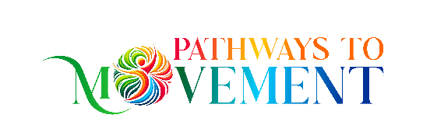

Individual Functional Synthesis® Lessons for Children
The Pathways Process
Our goal is to create the best possible conditions for your child to learn, grow, and discover new possibilities.
NeuroMovement® is a learning process, and the way lessons are structured is designed to support meaningful progress while respecting each child’s individual needs and capacity.

A Series of Lessons
Individual Functional Synthesis® (FS) lessons for children are typically oﬀered as an initial series of ﬁve lessons scheduled relatively close together.
NeuroMovement® is a process that builds upon learning from one experience to the next. Especially at the beginning, having lessons closer together gives your child’s brain repeated opportunities to receive new information, create new connections, and build upon what was learned in previous lessons.
A single lesson can certainly be valuable; however, lessons that are spaced too far apart—particularly when a child is ﬁrst beginning the process—may not provide the continuity needed to support the progress and changes we are seeking.
Following the initial series, we can assess your child’s response and progress together and determine what schedule may best support their continued learning.

Length of Lessons
Lessons typically last 35–45 minutes, depending on your child, their needs, and how they are responding that day.

NeuroMovement® provides the child with a rich learning experience rather than asking them to perform or repeat exercises. Because every child is diﬀerent, there may be times when a child reaches their capacity for learning before the scheduled lesson time is complete.
When this happens, ending the lesson earlier is intentional and beneﬁcial. The brain and nervous system need time to rest, integrate, and organize the new information they have received. Continuing beyond the point at which a child can comfortably engage does not necessarily create greater beneﬁt and may overwhelm the learning process.
The goal is not to ﬁll a certain number of minutes—it is to create the highest-quality learning experience possible for your child.

A Resource for Parents and Caregivers
As a parent, caregiver, or guardian, you will receive a copy of Anat Baniel’s Kids Beyond Limits to read as part of the process.
Understanding the principles behind NeuroMovement® can help you recognize what is happening during your child’s lessons and deepen your understanding of how learning and change occur.
Most importantly, it can provide you with practical insights and tools that you can bring into your child’s everyday environment, allowing the learning process to extend beyond the lesson itself and into daily life.

Parent & Caregiver Coaching
Parents and caregivers are an integral part of the child’s learning environment. For this reason, I also provide parent and caregiver coaching outside of your child’s individual lessons.

Coaching may take place by phone and provides an opportunity to discuss what you are observing, ask questions, explore challenges that may arise at home, and learn ways to support your child using the principles of NeuroMovement.
My intention is for us to work together as a team—supporting not only what happens during your child’s lessons, but also creating opportunities for learning, connection, and growth in everyday life.

